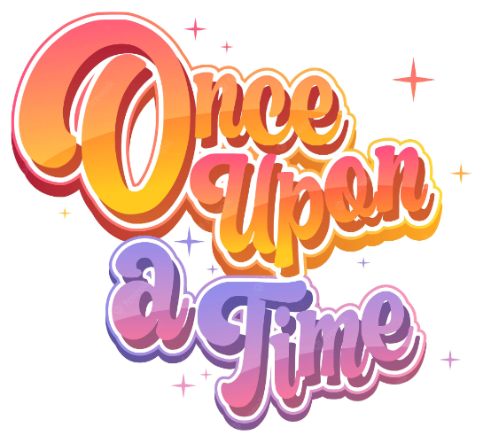

Our weekly focus:

Week 1: Goldilocks

Week 2: Goldilocks & Sleeping Beauty

Week 3: Sleeping Beauty

Week 4: The Gingerbread Man

Week 5: You choose Fairytales

Week 6: Dragon Dance

Expressive Art and Design

* Use printing technique to create a castle wall pattern
* Make use of props and materials when performing stories
* Adapt and recount narratives
* Make Gingerbread Men
* Design something for the Gingerbread Man to cross the river
* Musical stories
* Moving to music

Personal Social and Emotional Development

* To understand perseverance when tackling a challenge
* To be able to talk about a  time that they didn’t give up
* To be able to set a goal and work towards it
* To use kind words to encourage people
* To know what it means to feel proud of themselves

Literacy

* Write our name
* Form uppercase letters
* Write simple phrases
* Using known letter sounds
* Help change the role play area with recognisable print and signs
* Mark making and explaining meaning

Further experiences

* Waddesdon Manor class trip- fun with fairytales
* Mental health week

Maths

* Introducing zero
* Comparing numbers to 5
* Composition of 4 and 5
* Compare Mass
* Compare capacity
* 6,7,8
* Combining 2 amounts

Understanding the world

* Gingerbread Men - floating and sinking experiment (baked/unbaked)
* Which materials float? Which materials sink?
* Changing states of matter - baked/unbaked/solid/liquid chocolate to decorate
* Key Question: How do people celebrate? **Religion:** Hinduism