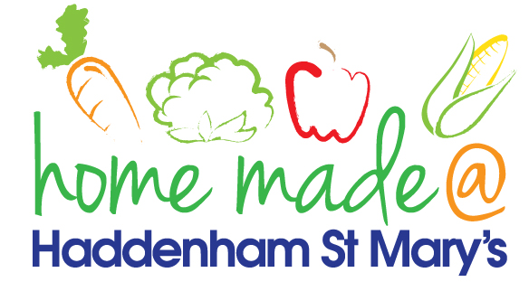

**MENU – week commencing 21st October**

**\*\*Please note that the fish on a Friday may be substituted for a similar fish on the day due to current supply issues\*\***

|  |  |  |  |  |  |
| --- | --- | --- | --- | --- | --- |
|  | **Meat Free Monday** | **Tuesday**  **Choose Day** | **Wonderful**  **Roast Wednesday** | **Thursday**  **Joyful Jackets** | **Friday**  **INSET DAY** |
| Lunch | Vegan sausage roll with rosti and vegetables | Lasagne with garlic bread | Roast Gammon with all the trimmings | Jacket potato with a choice of toppings |  |
| Vegetarian Option | Vegan sausage roll with rosti and vegetables | Vegetable lasagne with garlic bread | Roast Quorn with all the trimmings | Jacket potato with a choice of toppings |  |
| Dessert | Fruit | Jelly | Apple Cake | Fruit |  |
| Free From  Option | Heck sausage with chips and vegetables | Burger pasta bake | Roast Gammon with all the trimmings | Jacket potato with a choice of toppings |  |
| Free From Dessert | Fruit | Jelly | Fruit smoothie | Fruit |  |
|  | **All meals will contain or be served with at least one portion of vegetables.**  **All roast dinners, sausage & mash and pie dishes will have the option of extra gravy.**  **Please note that we may sometimes have to provide a similar substitute at short notice due to supply issues.** | | | | |