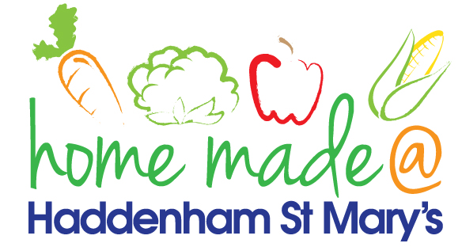

**MENU – week commencing 10th March **Please note that the fish on a Friday may be substituted for a similar fish on the day due to current supply issues\*\***

|  |  |  |  |  |  |
| --- | --- | --- | --- | --- | --- |
|  | **Meat Free Monday** | **Tuesday**  **Choose Day** | **Wonderful**  **Roast Wednesday** | **Thursday**  **Joyful Jackets** | **Friday**  **Fish Friday** |
| Lunch | Cheesy pizza with wholemeal base, carrots and cucumber sticks | Hunters chicken pasta bake with sweetcorn | Toad in the hole with mash and carrots | Jacket potato with a choice of toppings | Cod fillet with steak cut chips and peas |
| Vegetarian Option | Cheesy pizza with carrots and cucumber sticks | Lentil pasta with sweetcorn | Vegetable sausage with mash and carrots | Jacket potato with a choice of toppings | Vegetable paella |
| Dessert | Chocolate and vanilla swirl mousse | Fruit topped jelly | Fruit | Fruit | Choc chip cookie |
| Free From  Option | Cheesy pizza with carrots and cucumber sticks | Hunters chicken pasta bake with sweetcorn | Toad in the hole with mash and carrots | Jacket potato with a choice of toppings | Fish fingers, chips and vegetables |
| Free From Dessert | Chocolate dessert pudding | Fruit topped jelly | Fruit | Fruit | Cookie |
|  | **All meals will contain or be served with at least one portion of vegetables.**  **All roast dinners, sausage & mash and pie dishes will have the option of extra gravy.**  **Please note that we may sometimes have to provide a similar substitute at short notice due to supply issues.** | | | | |