DISHES AND THEIR ALLERGEN CONTENT – Homemade@Haddenham St Mary’s PUDDINGS Spring 1
All free from menu options are free from gluten and dairy products – for further information please email homemade@haddenham-st-marys.bucks.sch.uk
DISHES | 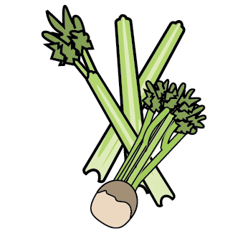 | 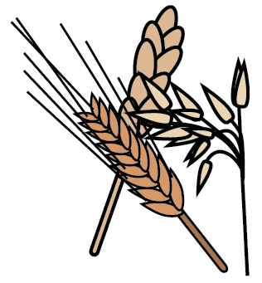 | 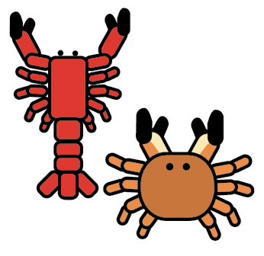 |  |  | 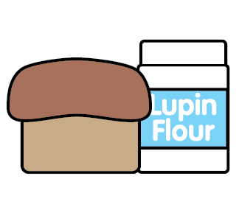 |  | 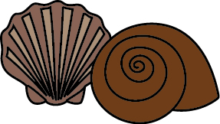 | 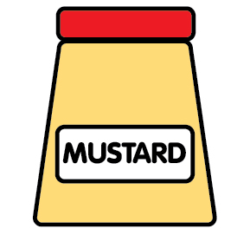 | 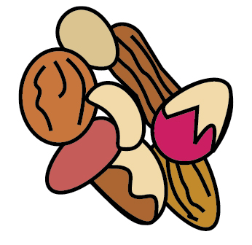 | 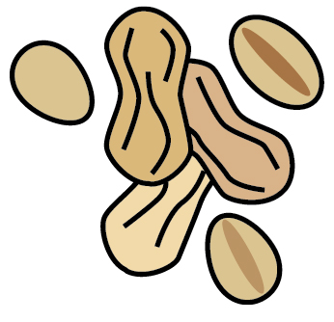 | 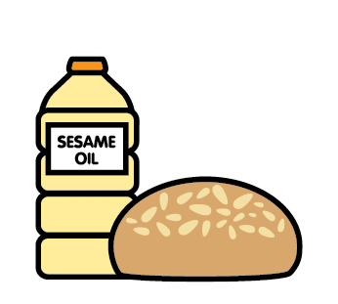 |  | 
 | Celery | Cereals containing gluten | Crustaceans | Eggs | Fish | Lupin | Milk | Mollusc | Mustard | Nuts | Peanuts | Sesame seeds | Soya | Sulphur Dioxide
Apple crumble |  | ✓ |  | ✓ |  |  | ✓
Blueberry muffin |  | ✓ |  | ✓ |  |  | ✓
Chocolate fork biscuit |  | ✓ |  | ✓ |  |  | ✓
Choc chip cookie |  | ✓ |  | ✓ |  |  | ✓
Flapjack |  | ✓ |  | ✓ |  |  | ✓
Fresh fruit
Rice pudding |  | ✓ |  | ✓ |  |  | ✓
School cake |  | ✓ |  | ✓ |  |  | ✓
Sponge and custard |  | ✓ |  | ✓ |  |  | ✓
Strawberry mousse |  | ✓ |  | ✓ |  |  | ✓
Traybake |  | ✓ |  | ✓ |  |  | ✓
Yoghurt |  |  |  |  |  |  | ✓

Review date: | 22/11/24 | Reviewed by: | C.Cartmell / K.Caesar-Gordon |  | You can find this template, including more information at www.food.gov.uk/allergy

