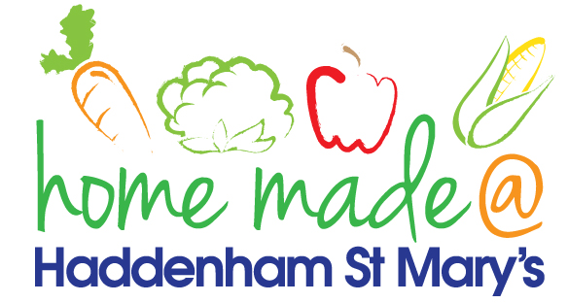

MENU – week commencing 19th February 2024
**Please note that the fish on a Friday may be substituted for a similar fish on the day due to current supply issues**
 | Meat Free Monday | Tuesday  Choose Day | Wonderful  Roast Wednesday | Thursday  Joyful Jackets | Friday  Fish Friday
Lunch | Pasta with a choice of toppings | Italian chicken with colourful rice | Roast gammon with all the trimmings | Jacket potato with a choice of toppings | Fish cakes, chips and vegetables
Vegetarian Option | Pasta with a choice of toppings | Italian vegetable stew with rice | Roast quorn with all the trimmings | Jacket potato with a choice of toppings | Vegetable burger, chips and vegetables
Dessert | Peach slices | Flapjack | Fruit | Angel Delight | Homemade jammy biscuits
Free From  Option | Pasta with a choice of toppings | Italian chicken with colourful rice | Roast gammon with all the trimmings | Jacket potato with a choice of toppings | Fish fingers, chips and vegetables
Free From Dessert | Peach slices | Fruit smoothie | Fruit | Jelly | Traybake
All meals will contain or be served with at least one portion of vegetables.
All roast dinners, sausage & mash and pie dishes will have the option of extra gravy.
Please note that we may sometimes have to provide a similar substitute at short notice due to supply issues.

