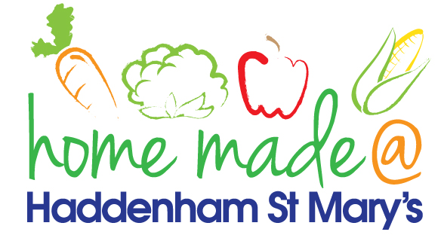

MENU – week commencing 29th April 2024
**Please note that the fish on a Friday may be substituted for a similar fish on the day due to current supply issues**
 | Meat Free Monday | Tuesday  Choose Day | Wonderful  Roast Wednesday | Thursday  Joyful Jackets | Friday  Fish Friday
Lunch | Cheesy Pizza with vegetable sticks | Chicken Fajita with rice | Roast Beef with all the trimmings | Jacket potato with a choice of toppings | Fish Burger  chips and vegetables
Vegetarian Option | Cheesy Pizza with vegetable sticks | Quorn Fajita with rice | Vegetable Pie with all the trimmings | Jacket potato with a choice of toppings | Vegetarian Sausage chips and vegetables
Dessert | Yoghurt | Fruit | Gingerbread Diamonds | Fruit | Oat and Raisin Cookies
Free From  Option | Cheesy Pizza with vegetable sticks | Chicken Fajita with rice | Roast Beef with all the trimmings | Jacket potato with a choice of toppings | Fish fingers, chips and vegetables
Free From Dessert | Fruit Smoothie | Fruit | Traybake | Fruit | Peach Slices
All meals will contain or be served with at least one portion of vegetables.
All roast dinners, sausage & mash and pie dishes will have the option of extra gravy.
Please note that we may sometimes have to provide a similar substitute at short notice due to supply issues.

