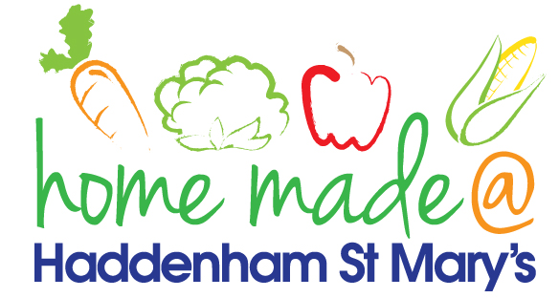

**MENU – week commencing 22nd July 2024**

**\*\*Please note that the fish on a Friday may be substituted for a similar fish on the day due to current supply issues\*\***

|  |  |  |  |  |  |
| --- | --- | --- | --- | --- | --- |
|  | **Meat Free Monday** | **Tuesday**  **Choose Day** | **SUMMER HOLIDAY** | **SUMMER HOLIDAY** | **SUMMER HOLIDAY** |
| Lunch | Rainbow cheesy pizza | Sausage in a bun with vegetable sticks |  |  |  |
| Vegetarian Option | Rainbow cheesy pizza | Vegetarian sausage in a bun with vegetable sticks |  |  |  |
| Dessert | Biscuit | Frozen mousse |  |  |  |
| Free From  Option | Rainbow cheesy pizza | Sausage in a bun with vegetable sticks |  |  |  |
| Free From Dessert | Fruit smoothie | Fruit |  |  |  |
|  | **All meals will contain or be served with at least one portion of vegetables.**  **All roast dinners, sausage & mash and pie dishes will have the option of extra gravy.**  **Please note that we may sometimes have to provide a similar substitute at short notice due to supply issues.** | | | | |