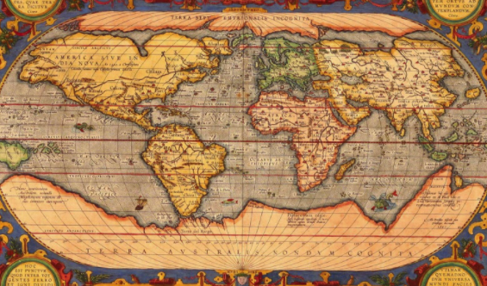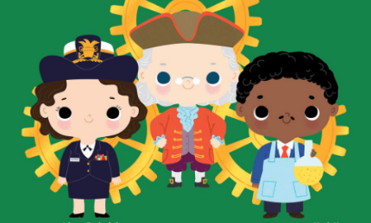

**English**

Fiction: The Dragon Machine

Non-fiction; Tim Berners-Lee

Poetry: themed for topic

Role-play and idea sharing

Handwriting

Supersonic phonic friends phonics

Grammar – use ‘and’, capital letters for proper nouns; adjectives for description

**Maths**

Using pictures and objects, including Numicon, to support and investigate numbers within 50

Measuring length, height, mass and volume

Problem solving

**Year 1**

**Spring Term 2**

**Inventors, designers and Explorers**

**Cross-curricular**

History- Lives of significant individuals - Tim Berners-Lee

The history of transport *(Wright Brothers, Benz, George Stephenson)*

Music – Instrumental, reggae, baroque.

PSHE – Values of coins and notes, needs and wants, looking after my money, understanding change.

Art/ DT – Aboriginal art - pointillism; William Morris - observational drawing and printing; Moving vehicles and moving easter cards (mechanisms - wheels, axles, sliders and levers)

**Non cross-curricular**

PE – Development of practical skills and team work; Dance

RE – Christianity; Palm Sunday

ICT –coding, researching, word processing, Purple Mash

**Science**

Animals including humans-

Classification, food chain, adaptations

Working scientifically:

-Asking Q’s

- Identifying and classifying

-Gathering and recording data