DISHES AND THEIR ALLERGEN CONTENT – Homemade@Haddenham St Mary’s MAINS – Spring 1 2025
All free from menu options are free from gluten and dairy products – for further information please email homemade@haddenham-st-marys.bucks.sch.uk
DISHES | 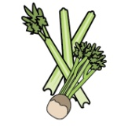 |  | 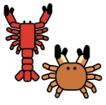 |  | 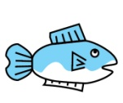 | 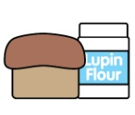 |  |  | 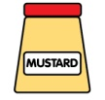 | 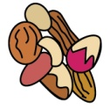 | 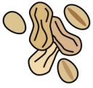 |  |  |  |  |  | 
 | Celery | Cereals containing gluten | Crustaceans | Eggs | Fish | Lupin | Milk | Mollusc | Mustard | Nuts |  | Peanuts |  | Sesame seeds | Soya |  | Sulphur Dioxide
Battered fish, chips and vegetables |  | ✓ |  | ✓ | ✓ |  | ✓
Breaded fish, chips/rosti/new potatoes and vegetables |  | ✓ |  | ✓ | ✓ |  | ✓
Cod bites, croquettes and vegetables |  | ✓ |  | ✓ | ✓ |  | ✓
Fish, chips and vegetables |  | ✓ |  | ✓ | ✓ |  | ✓
Fish burger, potato lattice/chips and vegetables |  | ✓ |  | ✓ | ✓ |  | ✓
Fishcake, chips/potato rosti and vegetables |  | ✓ |  | ✓ | ✓ |  | ✓
Fish fingers, chips/rosti/lattice and vegetables |  | ✓ |  | ✓ | ✓ |  | ✓
‘Free from’ fish fingers, new potatoes/chips and vegetables |  |  |  |  | ✓
‘Free from’ tuna and broccoli pasta bake |  |  |  |  | ✓
Garlic bread |  | ✓ |  |  |  |  | ✓
Glamorgan sausage |  | ✓ |  |  |  |  | ✓ |  |  |  |  |  |  |  |  | ✓
‘Free from’ tuna pasta bake |  |  |  |  | ✓
Jacket potato with a choice of fillings |  |  |  |  | ✓ |  | ✓
Jumbo fish finger, potato lattice/chips and vegetables |  | ✓ |  | ✓ | ✓ |  | ✓
Meatballs and spaghetti |  | ✓ |  | ✓ |  |  | ✓
Pasta bake with vegetables |  | ✓ |  | ✓ |  |  | ✓
Pasta with a choice of topping |  | ✓ |  | ✓ | ✓ |  | ✓
Quorn roast lunch |  | ✓ |  | ✓ |  |  | ✓ |  |  |  |  |  |  |  | ✓
Quorn roast sausage lunch |  | ✓ |  | ✓ |  |  | ✓ |  |  |  |  |  |  |  | ✓
Roast beef lunch |  | ✓ |  | ✓ |  |  | ✓
Roast falafel lunch |  | ✓ |  | ✓ |  |  | ✓
Roast gammon lunch |  | ✓ |  | ✓ |  |  | ✓
Roast sausage lunch |  | ✓ |  | ✓ |  |  | ✓
Spaghetti Bolognese and garlic bread |  | ✓ |  | ✓ |  |  | ✓
Tuna pasta bake |  | ✓ |  | ✓ | ✓ |  | ✓
Vegetable pasta bake |  | ✓ |  | ✓ |  |  | ✓
Veggie burger, potato rosti/chips/hash browns and vegetables |  | ✓ |  | ✓ |  |  | ✓ |  |  |  |  |  |  |  | ✓
Vegetable curry and rice |  | ✓ |  |  |  |  | ✓
Vegetable fingers, new potatoes/chips/croquettes/ rosti/crispers and vegetables |  | ✓ |  | ✓ |  |  | ✓
Veggie meatballs and spaghetti |  | ✓ |  | ✓ |  |  | ✓ |  |  |  |  |  |  |  | ✓
Veggie sausage roast lunch |  | ✓ |  | ✓ |  |  | ✓ |  |  |  |  |  |  |  | ✓
Vegetable pasta bake |  | ✓ |  |  |  |  | ✓

Review date: 20/11/24 |  | Reviewed by: | C.Cartmell / K.Caesar-Gordon |  | You can find this template, including more information at www.food.gov.uk/allergy

