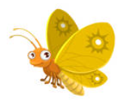

Expressive Art and Design

* Minibeast sewing
* Make clay minibeasts
* Observational drawings of minibeasts
* Water colour paintings of minibeasts
* Butterfly symmetry
* Listen to animal sounds

Personal Social and Emotional Development

* Express feelings about moving to Year 1
* Talk about worries and/or the things they are looking forward to about being in Year 1
* Share memories of the best bits in Reception

Our weekly focus:

Week 1: What is a mini-beast?

Week 2: Make a mini-beast.

Week 3: What do mini-beasts look like?

Week 4: What do mini-beasts eat?

Week 5: Where do mini-beasts live?

Week 6: Different animal homes.

Week 7: Moving on.

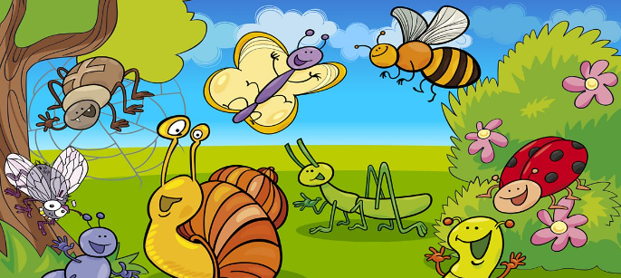

Further experiences

* Cotswold Wildlife Park
* The Grand Ball
* Sports Day
* Transition to Year 1
* Road Safety BRAKE
* Celebration open evening

Literacy

* Using a capital letter, full stop and finger spaces
* Write short sentences with words with known sound-letter correspondence
* Re-read what they have written to check that it makes sense
* Write with correct letter formation

Understanding the world

* Key Question: What makes places special?
* **Religion:** Christianity, Islam, Judiasm
* Minibeast hunt
* Pond dipping
* What do animals eat, look like and where they live?
* Cooking

Maths

* Spatial reasoning
* Visualise and build
* Deepening understanding
* Patterns and relationships
* Spatial reasoning
* Mapping
* Doubling, sharing and grouping
* Even and odd