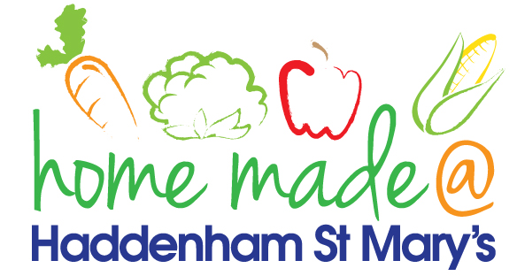

**MENU – week commencing 24th February **Please note that the fish on a Friday may be substituted for a similar fish on the day due to current supply issues\*\***

|  |  |  |  |  |  |
| --- | --- | --- | --- | --- | --- |
|  | **Meat Free Monday** | **Tuesday**  **Choose Day** | **Wonderful**  **Roast Wednesday** | **Thursday**  **Joyful Jackets** | **Friday**  **Fish Friday** |
| Lunch | Nut free pesto pasta with garlic bread with cherry tomatoes | Mini chicken fillet with potato wedges and peas | Roast gammon with all the trimmings | Jacket potato with a choice of toppings | Salmon fishcake with herby potatoes and carrots |
| Vegetarian Option | Nut free pesto pasta with garlic bread with cherry tomatoes | Veggie bake with potato wedges and peas | Crunchy vegetable pie with all the trimmings | Jacket potato with a choice of toppings | Broccoli bake with herby potatoes and carrots |
| Dessert | Selection of shortbread | Yoghurt | Flapjack | Fruit | Jelly |
| Free From  Option | Nut free pesto pasta with garlic bread with cherry tomatoes | Mini chicken fillet with potato wedges and peas | Crunchy vegetable pie with all the trimmings | Jacket potato with a choice of toppings | Fishcake with herby potatoes and carrots |
| Free From Dessert | Traybake | Yoghurt | Flapjack | Fruit | Jelly |
|  | **All meals will contain or be served with at least one portion of vegetables.**  **All roast dinners, sausage & mash and pie dishes will have the option of extra gravy.**  **Please note that we may sometimes have to provide a similar substitute at short notice due to supply issues.** | | | | |