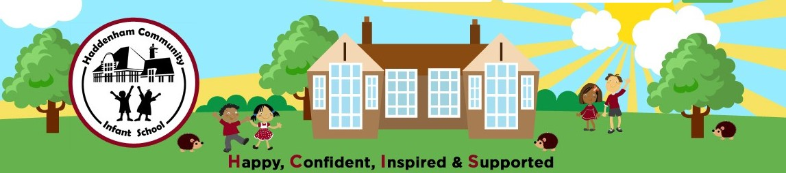

**TRAVELWISE WEEK (16TH – 22ND SEPT)**

**Scavenger Hunt**

As you walk to school look out for the items on the hunt and tick them off the chart when you have spotted them. Try to find as many items as you can and if you find more than one of each you can start a tally. Children will receive a walk to school badge for completing the Scavenger Hunt.

**Have fun walking to school!!**

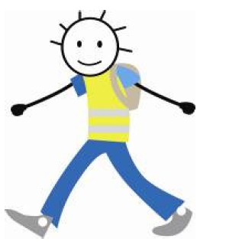

**Name: Class:**

|  |  |  |  |  |  |
| --- | --- | --- | --- | --- | --- |
|  | Monday | Tuesday | Wednesday | Thursday | Friday |
| 1. Bicycle |  |  |  |  |  |
| 2. Cat |  |  |  |  |  |
| 3. For sale sign |  |  |  |  |  |
| 4. White van |  |  |  |  |  |
| 5. Pushchair |  |  |  |  |  |
| Child on Scooter Silhouette SVG Clipart Boy Playing Digital - Etsy UK6. Scooter |  |  |  |  |  |
| 7. Dog |  |  |  |  |  |
| 8. Red car |  |  |  |  |  |
| Free Gate Clipart Black And White, Download Free Gate Clipart Black And  White png images, Free ClipArts on Clipart Library9. Wooden gate |  |  |  |  |  |
| Bus Black and White Clip Art Free PNG Image｜Illustoon10. Bus or coach |  |  |  |  |  |