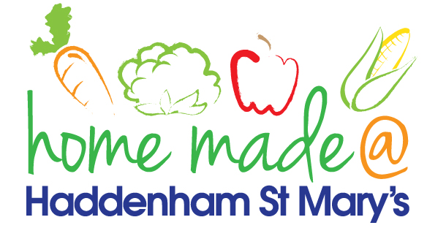

MENU – week commencing 25th March 2024
**Please note that the fish on a Friday may be substituted for a similar fish on the day due to current supply issues**
 | Meat Free Monday | Tuesday  Choose Day | Wonderful  Roast Wednesday | Thursday  Joyful Jackets
Lunch | Cheesy Pizza with vegetable sticks | Chilli with rice and nachos | Roast Gammon with all the trimmings | Jacket potato with a choice of toppings
Vegetarian Option | Cheesy Pizza with vegetable sticks | Vegetable Chilli with rice and nachos | Roast Quorn with all the trimmings | Jacket potato with a choice of toppings
Dessert | Flapjack | Yoghurt | Fruit | Choc Chip Cookies
Free From  Option | Cheesy Pizza with vegetable sticks | Chilli with rice and nachos | Roast Gammon with all the trimmings | Jacket potato with a choice of toppings
Free From Dessert | Fruit Smoothie | Jelly | Fruit | Traybake
All meals will contain or be served with at least one portion of vegetables.
All roast dinners, sausage & mash and pie dishes will have the option of extra gravy.
Please note that we may sometimes have to provide a similar substitute at short notice due to supply issues.

