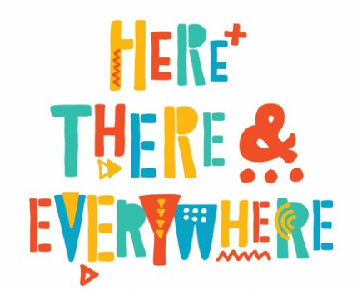

Personal Social and Emotional Development

* To know how to make friends
* Think of ways to solve problems and stay friends
* Start to understand the impact of unkind words
* Know how to be a good friend

Our weekly focus:

Week 1: Walk

Week 2: Road transport

Week 3: Water transport

Week 4: Rail

Week 5: Air transport

Week 6: Space travel

Expressive Art and Design

* Make a small world play mat for “Rosie’s Walk” and local area
* Make a collage vehicle
* Observation drawings of old/new cars using charcoal
* Paint a picture of boat on the sea - colour mixing and representing movement
* Design a method of transport
* Paper mache hot air balloons
* Moving to music

Literacy

* Write our name with correct letter formation
* Form uppercase letters
* Write simple phrases
* Use known letter sounds
* Writing sounds for meaning
* Help change the role play area with recognisable print and signs
* Recognise print around Haddenham

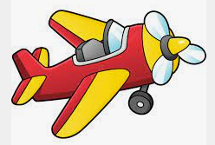

Further experiences

* Beckonscot class school trip
* World book day
* Science week
* Forest School on Wednesday PM

Maths

* Length and height
* Time
* Counting to 9 and 10
* Comparing numbers to 10
* Bonds to 10
* 3D shapes
* Spatial awareness
* Patterns

Understanding the world

* Key Question: What is Easter? **Religion:** Christianity
* Learn about St Davids’ day and St Patricks’ day
* Introduce maps
* Transport old and new
* Recognisable features of our village- Haddenham
* Similarities and differences about our country and other countries
* Beebot programming