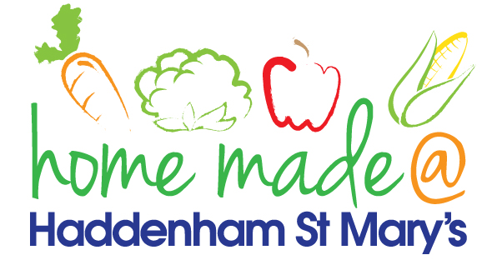

MENU – week commencing 26th February 2024
**Please note that the fish on a Friday may be substituted for a similar fish on the day due to current supply issues**
 | Meat Free Monday | Tuesday  Choose Day | Wonderful  Roast Wednesday | Thursday  Joyful Jackets | Friday  Fish Friday
Lunch | Tomato & Mascarpone Spaghetti Pot | Chilli with rice and nachos | Roast Sausage with all the trimmings | Jacket potato with a choice of toppings | Breaded Fish with chips and vegetables
Vegetarian Option | Tomato & Basil Spaghetti | Vegetable Chilli with rice and nachos | Roast Quorn Sausage with all the trimmings | Jacket potato with a choice of toppings | Vegetable Fingers with chips and vegetables
Dessert | Yoghurt | Fruit | Chocolate Concrete Cake | Fruit | Jelly
Free From  Option | Tomato & Basil Spaghetti | Chilli with rice and nachos | Roast Sausage with all the trimmings | Jacket potato with a choice of toppings | Fish fingers, chips and vegetables
Free From Dessert | Grapefruit | Fruit | Traybake | Fruit | Jelly
All meals will contain or be served with at least one portion of vegetables.
All roast dinners, sausage & mash and pie dishes will have the option of extra gravy.
Please note that we may sometimes have to provide a similar substitute at short notice due to supply issues.

