DISHES AND THEIR ALLERGEN CONTENT – Homemade@Haddenham St Mary’s PUDDINGS Spring 2
All free from menu options are free from gluten and dairy products – for further information please email homemade@haddenham-st-marys.bucks.sch.uk
DISHES | 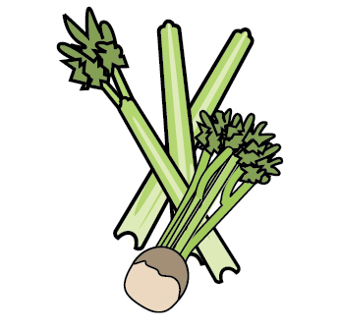 | 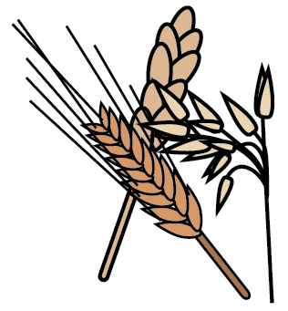 | 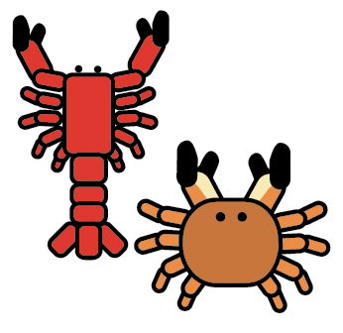 |  |  | 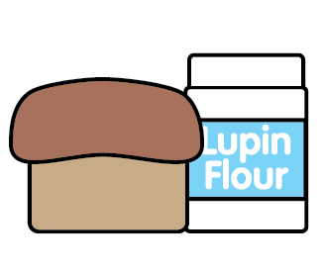 |  | 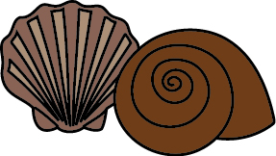 | 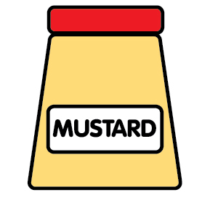 | 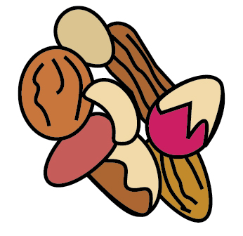 | 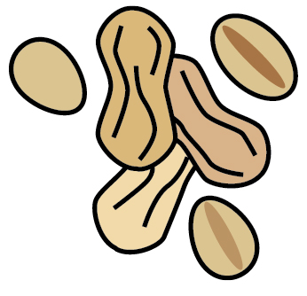 | 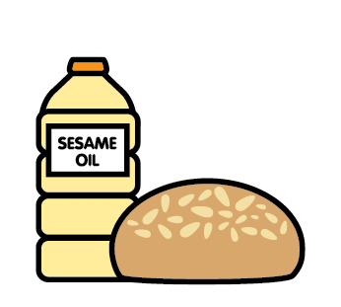 |  | 
 | Celery | Cereals containing gluten | Crustaceans | Eggs | Fish | Lupin | Milk | Mollusc | Mustard | Nuts | Peanuts | Sesame seeds | Soya | Sulphur Dioxide
Alpro chocolate dessert pudding |  |  |  |  |  |  |  |  |  |  |  |  | ✓
Choc chip muffin |  | ✓ |  | ✓ |  |  | ✓ |  |  |  |  | ✓ | ✓
Choc chip cookie |  | ✓ |  |  |  |  | ✓ |  |  |  |  |  | ✓
Chocolate and vanilla mousse |  |  |  |  |  |  | ✓
Flapjack |  |  |  |  |  |  | ✓
Jelly
Mixed flavour yoghurt |  |  |  |  |  |  | ✓
Oat and raisin cookie |  |  |  |  |  |  | ✓
Shortbread |  | ✓ |  |  |  |  | ✓
Strawberry mousse |  |  |  |  |  |  | ✓

Review date: | 22/01/25 | Reviewed by: | C.Cartmell / K.Caesar-Gordon |  | You can find this template, including more information at www.food.gov.uk/allergy

