DISHES AND THEIR ALLERGEN CONTENT – Homemade@Haddenham St Mary’s MAIN DISHES – Spring 2
All free from menu options are free from gluten and dairy products – for further information please email homemade@haddenham-st-marys.bucks.sch.uk
 | 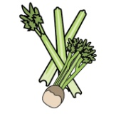 | 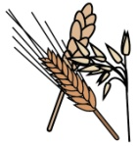 | 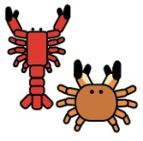 |  | 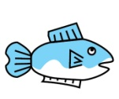 | 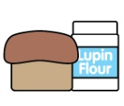 |  |  |  | 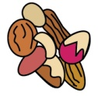 | 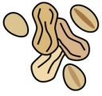 |  |  |  |  |  | 
 | Celery | Cereals containing gluten | Crustaceans | Eggs | Fish | Lupin | Milk | Mollusc | Mustard | Nuts |  | Peanuts |  | Sesame seeds | Soya |  | Sulphur Dioxide
MAINS:
Broccoli bake | ✓ | ✓ |  | ✓ |  |  | ✓ |  |  |  |  |  |  |  | ✓
Cauliflower cheese grill |  | ✓ |  |  |  |  | ✓
Cheesy pizza |  | ✓ |  |  |  |  | ✓
Crunchy vegetable pie | ✓ | ✓ |  | ✓ |  |  | ✓ |  | ✓ |  |  |  |  |  | ✓
Hunters chicken pasta bake |  | ✓ |  |  |  |  | ✓
Lentil pasta bake |  |  |  |  |  |  |  |  |  |  |  |  |  |  | ✓
Pork sausages |  | ✓ |  |  |  |  |  |  |  |  |  |  |  |  |  | ✓
Toad in the hole |  | ✓ |  | ✓ |  |  | ✓ |  |  |  |  |  |  |  |  | ✓
Tuna pasta bake |  |  |  |  | ✓
Vegetable paella
Vegetable sausage | ✓ | ✓
ROAST:
Beef
Gammon |  |  |  |  |  |  |  |  |  |  |  |  |  |  |  | ✓
Pork chipolatas |  | ✓ |  |  |  |  |  |  |  |  |  |  |  |  |  | ✓
FISH:
Cod fillet |  | ✓ |  |  | ✓ |  |  |  | ✓
Salmon fishcake |  | ✓ |  |  | ✓
Fishcake |  |  |  |  | ✓
Fishfinger |  |  |  |  | ✓
STARCHY FOODS:
Pasta |  | ✓
Rice
Chips
Rosti
Herby diced potatoes |  | ✓
Roast potatoes |  | ✓
Mashed potatoes |  |  |  |  |  |  | ✓
Potato wedges
Vegetable roast |  | ✓ |  | ✓
SAUCES:
Butter chicken sauce |  |  |  |  |  |  | ✓
Pesto |  |  |  |  |  |  | ✓

Review date: 22/01/25 |  | Reviewed by: | C.Cartmell / K.Caesar-Gordon | 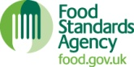 | You can find this template, including more information at www.food.gov.uk/allergy

