DISHES AND THEIR ALLERGEN CONTENT – Homemade@Haddenham St Mary’s PUDDINGS Spring 1 2024
All free from menu options are free from gluten and dairy products – for further information please email homemade@haddenham-st-marys.bucks.sch.uk
DISHES | 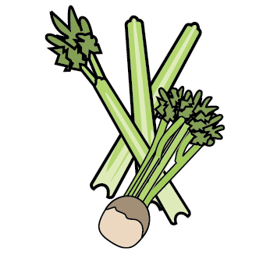 | 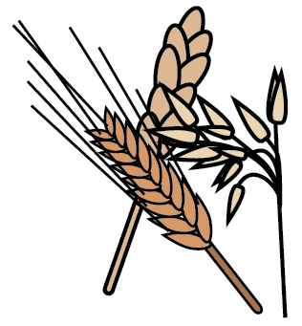 | 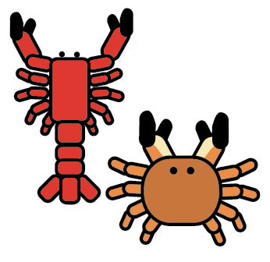 |  |  | 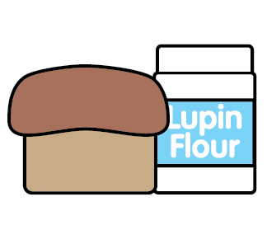 |  |  |  | 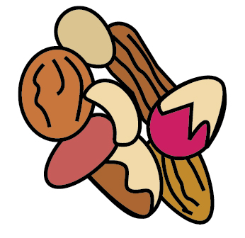 | 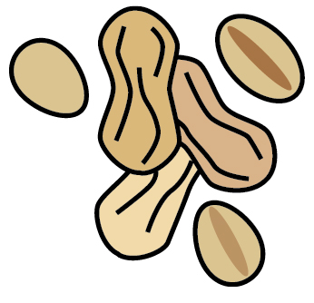 | 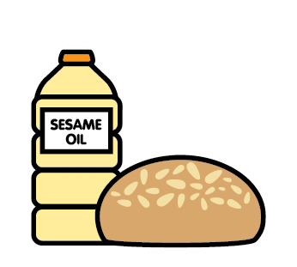 |  | 
 | Celery | Cereals containing gluten | Crustaceans | Eggs | Fish | Lupin | Milk | Mollusc | Mustard | Nuts | Peanuts | Sesame seeds | Soya | Sulphur Dioxide
Angel delight |  |  |  |  |  |  | ✓
Apple crumble |  | ✓ |  |  |  |  | ✓
Custard |  | ✓ |  | ✓ |  |  | ✓
Chocolate chip cookie |  | ✓ |  | ✓ |  |  | ✓
Chocolate concrete cake |  | ✓ |  | ✓ |  |  | ✓
Flapjack |  | ✓ |  |  |  |  | ✓
Fresh fruit
Fruit smoothie
Lemon cheesecake |  | ✓ |  | ✓ |  |  | ✓
Jelly
Muffin |  | ✓ |  | ✓ |  |  | ✓
Peaches in syrup
Peach crumble |  | ✓ |  |  |  |  | ✓
Shortbread |  | ✓ |  |  |  |  | ✓
Sponge |  | ✓ |  | ✓ |  |  | ✓
Vanilla biscuit |  | ✓ |  | ✓ |  |  | ✓
Yoghurt |  |  |  |  |  |  | ✓

Review date: | 17/11/23 | Reviewed by: | C.Cartmell / K. Caesar-Gordon |  | You can find this template, including more information at www.food.gov.uk/allergy

