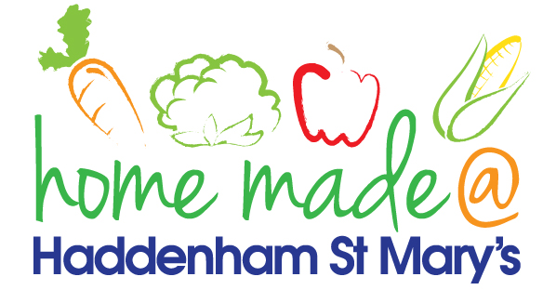

MENU – week commencing 4th March 2024
**Please note that the fish on a Friday may be substituted for a similar fish on the day due to current supply issues**
 | Meat Free Monday | Tuesday  Choose Day | Wonderful  Roast Wednesday | Thursday  Joyful Jackets | Friday  Fish Friday
Lunch | Cheesy Pizza with vegetable sticks | Cowboy Hotpot with wedges | Roast Beef with all the trimmings | Jacket potato with a choice of toppings | Tuna Pasta Bake
Vegetarian Option | Cheesy Pizza with vegetable sticks | Vegetable Cowboy Hotpot with wedges | Roast Quorn with all the trimmings | Jacket potato with a choice of toppings | Vegetable Pasta Bake
Dessert | Fruit Smoothie | Yoghurt | Fork Biscuits | Fruit | Apple Crumble with custard
Free From  Option | Cheesy Pizza with vegetable sticks | Vegetable Cowboy Hotpot with wedges | Roast Beef with all the trimmings | Jacket potato with a choice of toppings | Tuna Pasta Bake
Free From Dessert | Fruit Smoothie | Fruit | Jelly | Fruit | Traybake
All meals will contain or be served with at least one portion of vegetables.
All roast dinners, sausage & mash and pie dishes will have the option of extra gravy.
Please note that we may sometimes have to provide a similar substitute at short notice due to supply issues.

