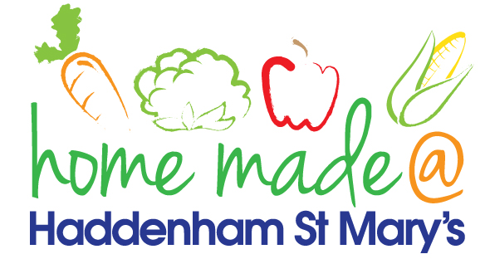

MENU – week commencing 13th May 2024
**Please note that the fish on a Friday may be substituted for a similar fish on the day due to current supply issues**
 | Meat Free Monday | Tuesday  Choose Day | Wonderful  Roast Wednesday | Thursday  Joyful Jackets | Friday  Fish Friday
Lunch | Pasta with a choice of toppings | Meatballs with rice | Roast Gammon with all the trimmings | Jacket potato with a choice of toppings | Jumbo Fish Fingers chips and vegetables
Vegetarian Option | Pasta with a choice of toppings | Quorn Meatballs with rice | Roast Quorn with all the trimmings | Jacket potato with a choice of toppings | Vegetable Burger chips and vegetables
Dessert | Apple Crumble with custard | Fruit | Oat and Raisin Cookie | Fruit | Custard Biscuit
Free From  Option | Pasta with a choice of toppings | Meatballs with rice | Roast Gammon with all the trimmings | Jacket potato with a choice of toppings | Fish fingers, chips and vegetables
Free From Dessert | Fruit Smoothie | Jelly | Traybake | Fruit | Pineapple
All meals will contain or be served with at least one portion of vegetables.
All roast dinners, sausage & mash and pie dishes will have the option of extra gravy.
Please note that we may sometimes have to provide a similar substitute at short notice due to supply issues.

