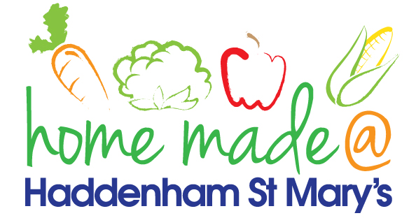

MENU – week commencing 6th May 2024
**Please note that the fish on a Friday may be substituted for a similar fish on the day due to current supply issues**
 | Bank Holiday | Tuesday  Choose Day | Wonderful  Roast Wednesday | Thursday  Joyful Jackets | Friday  Fish Friday
Lunch |  | Burger Pasta | Roast Sausage with all the trimmings | Jacket potato with a choice of toppings | Breaded Fish  chips and vegetables
Vegetarian Option |  | Quorn Pasta | Roast Quorn with all the trimmings | Jacket potato with a choice of toppings | Glamorgan Sausage chips and vegetables
Dessert |  | Peaches in Syrup | Chocolate Fork Biscuit | Fruit | Jam Doughnut
Free From  Option |  | Burger Pasta | Roast Sausage with all the trimmings | Jacket potato with a choice of toppings | Fish fingers, chips and vegetables
Free From Dessert |  | Peaches | Fruit Smoothie | Fruit | Jelly
All meals will contain or be served with at least one portion of vegetables.
All roast dinners, sausage & mash and pie dishes will have the option of extra gravy.
Please note that we may sometimes have to provide a similar substitute at short notice due to supply issues.

