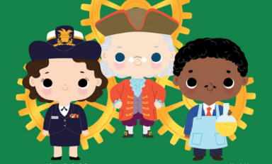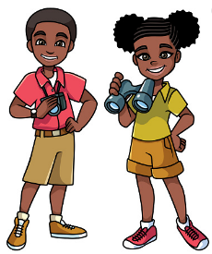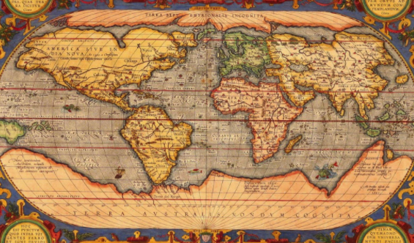

**Non cross-curricular**

PE – Development of practical skills and team work.

RE – Christianity; Was it always easy for Jesus to show friendship?

ICT –coding, researching, directional language, Purple Mash

**Cross-curricular**

Geography– Continents and Oceans, Antarctica and Arctic

History- Lives of significant individuals; Captain Cook and Captain Scott

Music – music around the world

PSHE – Gifts and talents, understanding jealousy, what is bullying?

Art/ DT –Aboriginal Art

**Maths**

Using pictures and objects, including Numicon, to support and investigate

Counting to 50 and beyond

Writing numbers to 50 and beyond

Greater than, Less than <>

Equality =

Number bonds to 20

Addition and Subtraction

Problem solving

Reading and writing numbers in digits and words

Exploring fractions

**English**

Fiction: Paddington Bear

Non-fiction; Diary writing, Instructions,

Role-play and idea sharing

Handwriting

Letters and sounds based phonics

Guided reading

Grammar – Imperative verbs (Bossy verbs) and time conjunctions

**Year 1**

**Spring Term 1**

**Inventors, designers and Explorers**

**Science**

Animals including humans-

Classification, food chain, adaptations

Working scientifically:

-Asking Q’s

- Identifying and classifying

-Gathering and recording data