Snow Activities!

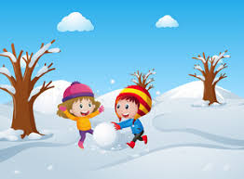

Using a stick write numbers or words in the snow. Maybe you could draw marks to show counting in the snow.

Draw different shapes in the snow.

If it is too cold to go outside then draw what you can see. Look really closely to see if you can spot any animals or plants covered in snow.

Draw a picture of what you did during the day and write a caption/sentence to go with your drawing. Don't forget 'Think it, say it, write, read it!'

Design a snowman that would stand out and be the best snowman
in all of Haddenham.
Write a sentence to explain why it is the best snowman.

Have fun, be safe and see you soon.

