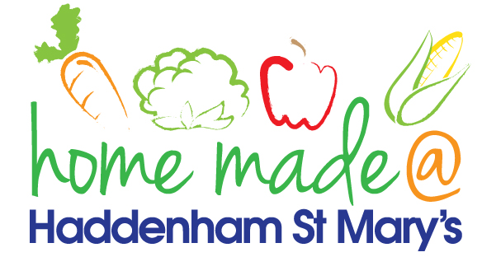

MENU – week commencing 18th March 2024
**Please note that the fish on a Friday may be substituted for a similar fish on the day due to current supply issues**
 | Meat Free Monday | Tuesday  Choose Day | Wonderful  Roast Wednesday | Thursday  Joyful Jackets | Friday  Fish Friday
Lunch | Tomato & Mascarpone Spaghetti Pot | Italian Chicken with colourful rice | Roast Sausages with all the trimmings | Jacket potato with a choice of toppings | Jumbo Fish Finger with chips and vegetables
Vegetarian Option | Tomato & Mascarpone Spaghetti Pot | Italian Vegetable Stew with rice | Roast Vegetarian Sausage with all the trimmings | Jacket potato with a choice of toppings | Vegetable Fingers with chips and vegetables
Dessert | Yoghurt | Homemade Jammy Biscuits | Fruit | Jelly | Custard Biscuits
Free From  Option | Tomato & Mascarpone Spaghetti Pot | Italian Chicken with colourful rice | Roast Sausage with all the trimmings | Jacket potato with a choice of toppings | Fish fingers, chips and vegetables
Free From Dessert | Peach Slices | Fruit Smoothie | Fruit | Jelly | Traybake
All meals will contain or be served with at least one portion of vegetables.
All roast dinners, sausage & mash and pie dishes will have the option of extra gravy.
Please note that we may sometimes have to provide a similar substitute at short notice due to supply issues.

