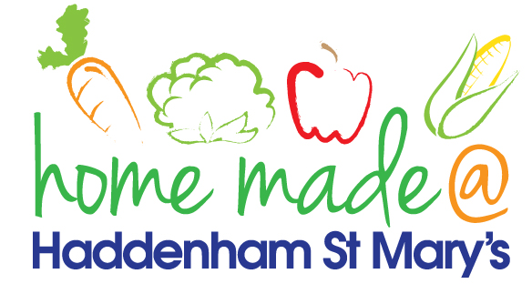

MENU – week commencing 15th April 2024
**Please note that the fish on a Friday may be substituted for a similar fish on the day due to current supply issues**
 | Meat Free Monday | Tuesday  Choose Day | Wonderful  Roast Wednesday | Thursday  Joyful Jackets | Friday  Fish Friday
Lunch | Vegan Sausage Rolls with vegetables and crispers | Burger Pasta | Roast Sausage with all the trimmings | Jacket potato with a choice of toppings | Breaded Fish, chips and vegetables
Vegetarian Option | Vegan Sausage Rolls with vegetables and crispers | Quorn Pasta | Roast Veggie Sausage with all the trimmings | Jacket potato with a choice of toppings | Glamorgan Sausage, chips and vegetables
Dessert | Fruit Smoothie | Peaches in Syrup | Choc Chip Shortbread | Fruit | Sponge and Custard
Free From  Option | Heck Sausages with vegetables and crispers | Burger Pasta | Roast Sausage with all the trimmings | Jacket potato with a choice of toppings | Fish fingers, chips and vegetables
Free From Dessert | Fruit Smoothie | Peaches | Jelly | Fruit | Traybake
All meals will contain or be served with at least one portion of vegetables.
All roast dinners, sausage & mash and pie dishes will have the option of extra gravy.
Please note that we may sometimes have to provide a similar substitute at short notice due to supply issues.

